FOUNDATION FOR VIRTUAL AND AUGMENTED REALITY SYSTEMS
Lecture18
Lec-18: Understanding Tracking II
Hello and welcome to the NPTEL MOOC's course on Virtual and Augmented Reality Systems, Foundation for Virtual and Augmented Reality Systems. We are currently discussing tracking in lecture number 9. So, we will continue our discussion on tracking. So far, what we have covered, let us quickly recap. In this lecture, in the earlier parts of the lecture, what we have covered are
We started our discussion with the basic idea of tracking, what tracking is all about, and then we covered so far. If you recollect that in the idea of tracking, we talked about what we track, that is either sense organs or other body parts of the user or objects in the surrounding. Then we talked about how it works; we started our discussion on that. And two parts of it we have covered so far, namely the broad category of tracking technologies that is inside out and outside in, and also the stages and brief understanding of those stages. In this lecture, we will conclude our discussion on tracking with some exposure to the various tracking technologies that are primarily used in the
VR and AR domain. Now, like various categorizations that we have seen so far, here also technology-wise, we can go for categorization of all the technologies that are used in VR or AR. So, we have electromechanical tracking devices. Then we have electromagnetic devices, acoustic or ultrasonic devices, vision-based tracking systems, inertial tracking systems, and others that are primarily hybrid of different techniques. So, we have electromechanical, electromagnetic, acoustic, vision-based, inertial, and
Anything else we can club together as others, which includes location-based as well as hybrid tracking technologies. Inertial, of course, if you recollect in our earlier discussion on how tracking works, we briefly introduced the inertial trackers. Other things we will briefly try to understand in this part of the lecture. Let us start with electromechanical trackers. Now, when we talk of electromechanical trackers, such trackers consist of a serial or parallel kinematic structure composed of links that are interconnected using joints with sensors.
Now, they can be of two types, two types: world-fixed or wearable, worn on the body of the user. World-fixed electromechanical trackers look something like the one shown here in this figure. Here, the display part, as you can see here, is attached to the electromechanically tracked setup, which is the part shown here, this entire thing. So, we have the display here schematically; the idea is illustrated here. We have the display here, then mechanical pivoting with tracking sensors attached in this whole setup, and then counterbalance to make it stable.
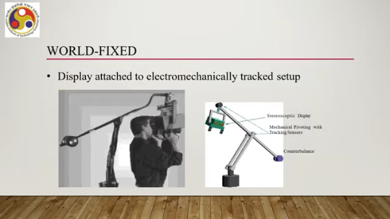
So, this is quite a cumbersome setup, as you can see from the image. The other category of electromechanical trackers are the wearable trackers, which can be worn on the body. So, when we see some animated avatars, these avatars are created using this type of tracker. So, real human beings wear these trackers and make movements, and those movements are tracked and translated to avatar movement in the virtual world. There are several products like IGS 190, Gypsy 6, Gypsy Gyro, exoskeleton tracker, and so on.
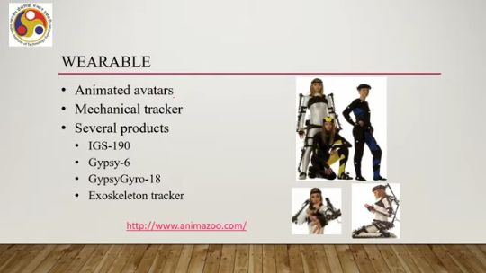
Some of these trackers are shown here, as you can see. They can be used in limited setups. Of course, they are not very comfortable to wear, quite cumbersome as they look, and are used in highly specialized setups. So, these are two types of electromechanical trackers. Next are electromagnetic trackers, which is the second category: electromagnetic trackers.
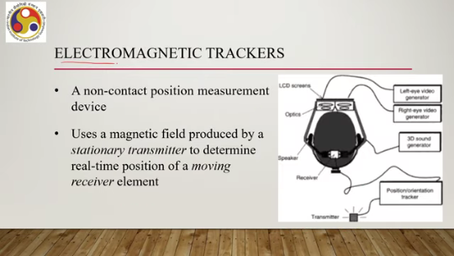
Here, what happens is that it is a kind of non-contact position measurement device. So, it tracks the position. It uses a magnetic field that is produced by a stationary transmitter. to determine the real-time position of a moving receiver element. So, the idea is schematically illustrated here.
So, suppose there is a headset as shown here with the display part here and speakers attached. Now, there is a receiver attached to the headset. In this schematic, of course, it is attached to the back side, and there is a transmitter somewhere in the environment. You can see it is connected; the transmitter is connected to the receiver through this wire here. Then, as the head moves, the transmitter is capable of generating a magnetic field; the transmitter is stationary in the environment; it is not moving.
However, with the head, the receiver moves and based on the magnetic field direction. The position can be obtained that is electromagnetic tracker. Sometimes the transmitter, so there can be different ways the transmitter can be designed. Generally there can be three antennas which can produce three orthogonal magnetic fields. And these fields generate currents in receivers, electric current.
Either AC or DC current can be used. So, there are different models that are available in the market based on the kind of current being generated. And these currents can help track the position of the head with respect to some fixed position in the environment. We can also have acoustic tracking that is the third category of trackers acoustic tracking. It uses ultrasonic signals.
So, it is also called ultrasonic tracking. Ultrasonic signals produced by stationary transmitter to determine real time position. Generally transmitters are we can also call them speakers and there are receivers you can call them microphones. Now, unlike the electromagnetic one here, so there are similarities with the electromagnetic trackers. In that, in both the cases transmitters are stationary whereas receivers are moving, moving with the head or with the user's body.
There the similarity ends. The dissimilarity is that Ultrasonic or acoustic tracking requires line of sight, that is, the transmitter and receiver should be within the line of sight. There should not be any obstacle in between, which is not the case with electromagnetic tracking. Schematically, the idea can be understood in this way.
So, there is a transmitter, ultrasonic speakers or transmitters, which are fixed in the environment somewhere. There can be a control unit which controls the transmission. A computer is there, and this is the receiver part which is attached to the HMD. So, based on the ultrasonic signal generated and received, the position or orientation of the head can be tracked. The fourth category, which is probably the most important category in the present context, is the vision-based tracker.
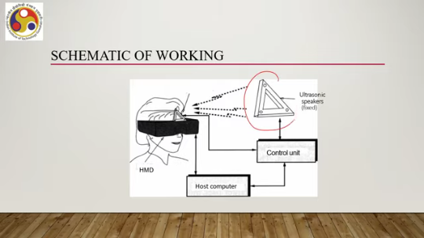
These are more prevalent nowadays. Now, in such trackers, poses such as position and orientation are determined; poses are determined using optical sensors or cameras. Now, there can be three main categories of optical sensors which can be deployed to detect the pose or to track the pose. One is infrared sensors, the second is visible light sensors, and the third is 3D structure sensors. So, we have these three categories of optical sensors: infrared, visible light, and 3D structure sensing.
Let us try to understand each of these in a little more detail. Let us begin with infrared tracking using infrared sensors that is the first of the three categories of vision-based sensing. So, infrared tracking can be considered to be among the earliest vision-based tracking techniques developed and used in VR or AR. It uses targets that emit or reflect light. In that way, such an arrangement makes detection easy due to high brightness compared to the surroundings.
Also, such an approach is robust to adverse illumination effects such as poor ambient lighting or harsh shadows. Since we are relying on infrared sensing rather than visible light sensing, adverse illumination effects such as poor ambient lighting or shadows do not have any effect on the tracking performance. Now, infrared tracking can be done in either of two ways. That is, outside looking in and inside looking out.
We have already introduced the idea before, and that idea is applicable for this type of infrared tracking system. Just to recap, in the case of outside looking in, what happens is that the targets are attached to objects that are being tracked with cameras external to the object. So, there are some targets which the cameras are tracking. Now, those targets are attached to the object being tracked, but the cameras that are tracking the objects are not attached to the object; instead, they are placed in the environment as shown here in this schematic.
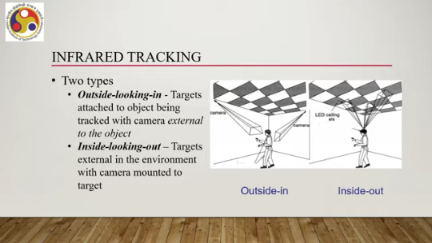
So, the cameras are placed in the environment at different locations, and the targets are attached to the user here in this schematic. The cameras are detecting the targets and based on that, detecting the pose and positions of the object. Then we have so that is outside in, then we have inside out. Similar idea here: the targets are external to the environment with the camera mounted to the target. So, in the case of inside-out, the camera is mounted with the user.
Targets are external. The camera detects the targets that are external and based on that estimates poses. That is infrared tracking. Then we have visible light tracking, which uses visible light sensors or optical cameras, which are the most common optical sensor type. We can find these cameras nowadays in almost all consumer-grade electronic devices, including laptops, smartphones, and tablet PCs.
Also, they are available in wearable devices. So, we have a very abundant supply of such sensors nowadays. Now, visible light tracking can further be classified into three types. Fiducial tracking, natural feature tracking, and model-based tracking. So, when we are talking about visible light tracking, we are essentially referring to three types of tracking techniques: fiducial tracking, natural feature tracking, and model-based tracking.
So, what happens in each of these? Let us try to understand. Let us begin with fiducial tracking. So, fiducials are essentially, as we all know, artificial landmarks added to the environment to aid in registration and tracking. Now, when we say fiducial tracking, we are adding some artificial landmarks in the environment so that we can track whatever we want to track.
Now, the complexity of the tracking process can vary considerably depending on the kind of fiducial we are using. So, we can use small colored LEDs or pieces of paper as fiducials, such as shown here: different kinds of colored, Pieces of paper or LEDs can be used as shown here or we can have multi rings for detection at greater distances. So, we can have proportional width ring fiducials as the distance changes the ring's appearance also changes. As shown here or constant width ring fiducials.
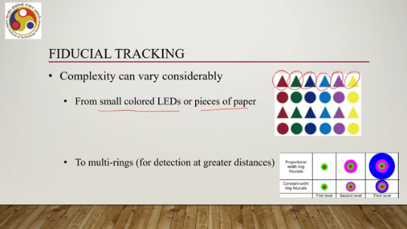
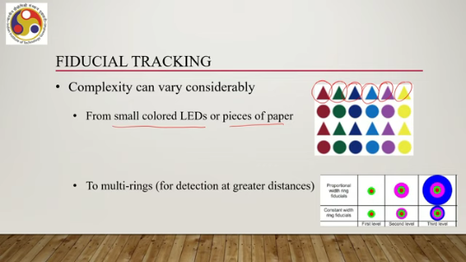
So, the ring width remains constant in all the fiducials. So, we can have different levels of complexity depending on the kind of fiducials that we are using. The next category of visual light based sensing is the natural feature tracking, that is the second category. So, we can register camera pose in real time using features that are already present in the natural environment. This requires usage of advanced image processing algorithms or in other words computer vision techniques.
Such algorithms detect features that are unique to the surroundings with respect to the object. For example, points, corners, line intersections and so on. They create unique descriptors which are calculated for each such feature. Now, such descriptors allow identification and differentiation of the The things from other features.
Identification of and differentiation from other features, that is the role of the unique descriptors that are calculated using the algorithms. And then, once the descriptors are there, they are used to estimate pose. Pose is computed by matching features detected in the scene with those detected in the object to be tracked. So, there are some quite popular natural feature detection and description algorithms. For example, shift or scale invariant feature transform, surf or speeded up robust features,
brief or binary robust independent elementary features, brisk or binary robust invariant scalable key points. So, these are namely SIFT, SURF, BRIEF, BRISK, some of the popular ones which can be utilized to perform natural feature tracking tasks. There are many more, of course. That is about natural feature tracking.
The third category of visible light sensing, visible light-based sensing, is the model-based tracking. So, in the last few years, there has been a significant interest seen in developing techniques that are able to simultaneously create and update a map of the real environment while localizing positions within it. This technique is called SLAM or Simultaneous Localization and Mapping. So, what happens is that using these techniques, we can create
a map of the environment and locate an object within the map, and as time passes, the map gets updated with the object's position changing. So, in other words, we can track in real time. In the last few years, this technique, broadly known as SLAM, has become quite popular. Now, this SLAM technique was originally developed for robot navigation, which has subsequently been adapted for augmented reality.
The technique allows drift-free tracking of unknown environments. It's quite powerful in that sense. Further optimizations of this SLAM technique led to PTAM, or Parallel Tracking and Mapping, which allows tracking of the camera and mapping of the environment as separate activities. Now, this technique, PTAM, has been specifically designed for augmented reality.
It improved both the accuracy of tracking and the overall performance and is more suited for small environments. The computational requirements for larger environments are quite high. So, it is more suitable for smaller environments. So, those are visible light-based tracking.
Another tracking technique is 3D structure tracking. Again, this is a recent phenomenon. In recent years, commercial sensors that are capable of detecting 3D structure information from the environment have become affordable. And this trend started with the introduction of the Microsoft Kinect device, which of course is not much supported nowadays, but similar devices are available. The sensors obtain information about the 3D positions of points in the scene using these types of devices.
An example of such a system, an AR system, is Kinect Fusion by Microsoft. It uses data obtained from Kinect's structured light depth sensor to create high-quality 3D models of real objects and environments. The models are also used for tracking the pose of the Kinect. The idea is illustrated here.
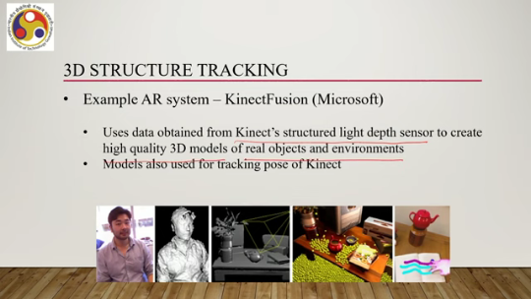
So, this is the original human being; this is a model. Similarly, models are created here. And then these models can be augmented with the real-world view. That is 3D structure sensing, or rather creating 3D models of the structures present in the environment and using them for augmentation of the real-world view. Another category of trackers which we have already introduced earlier are the inertial trackers.
These are self-contained sensors that measure rate of change in object orientation, translation velocity, or acceleration. One thing to be noted here is that it can measure only changes, not the absolute values. So, typically based on microelectromechanical systems or MEMS, technology, no range limitation can be there because those typically are part of the device that the user is using. So, there is no concern on range.
They are integrated into most smartphones and HMDs nowadays. So, you can readily use such sensors for tracking. Earlier, we have seen what the inertial sensors are: gyroscopes, accelerometer, magnetometer. These are the primary sensors; using these, some hybrid software-level sensors can be designed and can be part of the device, but the primary ones are gyroscope, accelerometer, and magnetometer. Those are the basic types of sensors.
that are typically used: electromechanical, electromagnetic, inertial, 3D structure sensing, light based sensing and so on. Now there are some other sensors which do not directly fit into any of these categories. One other sensing is acoustic sensing. So there are some other sensors which do not directly fit into any of these categories. For example, GPS, which also allows us to track positions.
So, it is a positional tracking device, particularly useful in outdoor environments. In indoor environments, the accuracy may not be at the desirable level. Now, it is also possible that whatever basic GPS sensor is available, we can on top of it use some enhancement technologies to improve the detection accuracy further. For example, RTK or real time kinematic technology can be used, which uses GPS signal carrier waves for measurement and can provide further accuracy compared to the basic GPS system.
The problem with GPS is that they generally offer GPS trackers that generally offer low accuracy, particularly in the Indoor environment and only allows positional tracking; no other tracking is there. It is typically utilized when accurate position registration is not so important, approximation is good enough, or it can be used as part of a hybrid tracking system with some other tracking systems. Motion capture: earlier we talked about motion capture suits while discussing VR hardware. So, those also come with tracking sensors.
So, motion capture essentially refers to the technique of digitally recording movements of real things, usually humans. Now, it can be based on any tracking method. So, as such, we cannot say that this is a fundamentally new tracking method. However, they are packaged in a different way, as wearable suits. When users wear them and make movements, those are recorded.
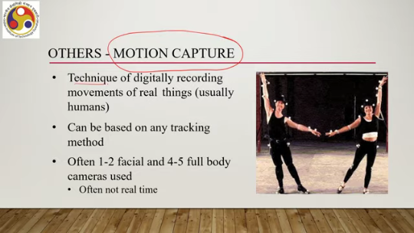
So, typically one or two facial trackers and four or five full body tracking devices, which can be cameras, are used. It need not be real-time tracking; it can be non-real-time tracking as well. Then we can have eye-tracking systems as part of other trackers. This can be head-mounted or remotely attached to the display or external display. It utilizes optical tracking.
with high-resolution camera-based tracking device. But there can be other techniques utilized such as infrared lighting-based eye tracking, electro-oculography or EOG, video-oculography or VOG techniques, and so on. Such trackers typically track the gaze point or area of the gaze of the user. Any other tracker we can roughly call hybrid trackers. Some of the trackers that we have already discussed, emotion capture, are already hybrid trackers, but there can be other hybrid tracking methods.
We can combine one or more of the earlier basic tracking methods to come up with hybrid tracking methods. So, whenever some tracking method utilizes two or more basic tracking systems, tracking approaches, then we call it hybrid trackers. Typically, it has been found that hybrid trackers perform better than single-technology-based tracking. So, that is what different technologies are there being used in the
in tracking either users, sense organs, body parts, or objects in the environment. So, we have gone through the most prominent ones. So, we have talked about different tracking technologies in this part. So, in this overall lecture, what we have learned again, to summarize, is the basic idea of tracking we have learned. Then we talked about how tracking is done and finally, what technologies are prevalent today when tracking is done in VR or AR.
In the next lecture, we will cover VR software. So, in the previous three lectures, we have covered the hardware part of the technologies: VR hardware, AR hardware. The tracking hardware that is typically used, with a basic understanding of tracking. Now we will start our discussion from the next lecture onwards on the software part. I hope you have understood the concepts, you have enjoyed it, and these are the references that I have utilized while identifying or discussing the topics.
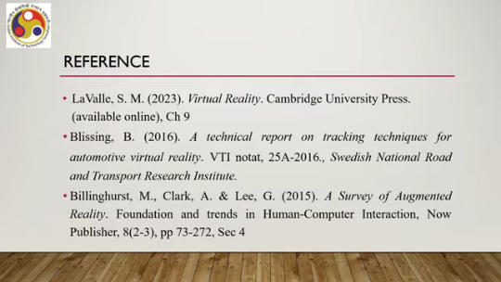
You can go through them. So there are three references mentioned: Lovell, Blissing et al., and Billinghurst et al. These are references from where materials for this lecture are taken. If you go through them, that will be good. You can get more details.
So I hope you have understood the concepts and enjoyed. Looking forward to meeting you again in the next lecture. Till then, thank you and goodbye. Happy learning.

